MediSlot Milestone 1 Design Document
AWS Services and Responsibilities
AWS Service | Responsibility
Amazon EC2 with Flask | Hosts the doctor and patient portals.
Amazon API Gateway | Provides a single-entry point for API requests.
AWS Lambda Authorizer | Validates access tokens and user roles.
Authentication Lambda | Handles registration, login, token refresh, and logout.
Doctor Lambda | Creates and updates doctor profiles.
Patient Lambda | Manages patient profiles.
Booking Lambda | Books appointments and prevents duplicate bookings.
Patient Cancellation Lambda | Processes patient appointment cancellations.
Doctor Cancellation Lambda | Processes doctor-initiated cancellations.
Reschedule Lambda | Initiates and coordinates appointment rescheduling.
AWS Step Functions | Manages rescheduling steps and compensation for failures.
Amazon RDS for MySQL | Stores user profiles, hospital information, appointments, and refund records.
Amazon DynamoDB | Stores appointment slots, waitlists, hold offers, idempotency records, and token-related records.
Amazon S3 | Stores doctor profile photos, application files, and reports.
AWS Systems Manager Parameter Store | Stores application configuration and secrets.
Amazon EventBridge | Routes appointment and cancellation events.
Amazon EventBridge Scheduler | Triggers slot generation, reminders, and scheduled expiry checks.
Amazon SQS and DLQs | Buffer asynchronous messages and capture repeatedly failed messages.
Amazon SNS | Publishes patient and doctor notifications.
Amazon CloudWatch | Collects logs, metrics, dashboards, and alarms.
AWS IAM and GitHub OIDC | Manage AWS permissions and secure deployment access.
AWS CloudFormation | Creates and updates AWS infrastructure.
GitHub Actions | Automates validation, testing, and deployment.
AWS Budgets | Monitors AWS costs and budget alerts.

VPC Layout
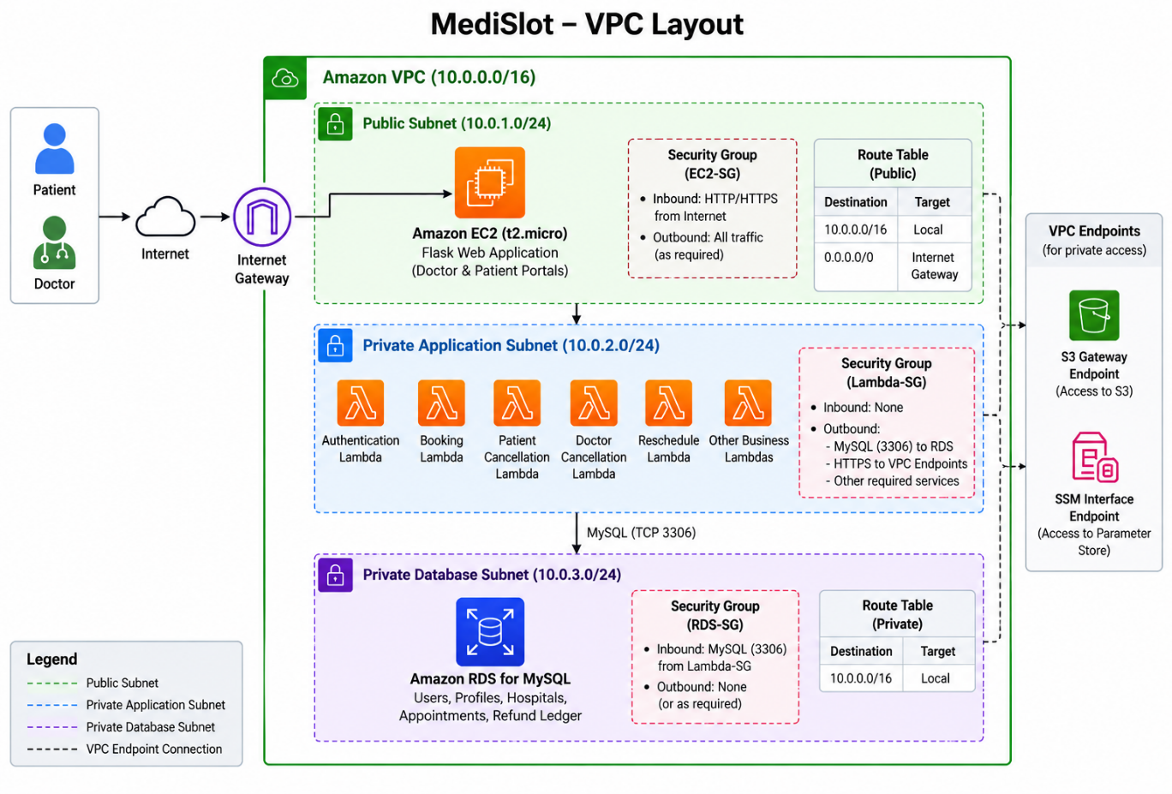

The Amazon VPC provides network isolation for MediSlot resources.
Component | Responsibility
Public subnet | Hosts the EC2 Flask dashboard.
Private application subnets | Provide private network access for Lambda functions that require access to RDS.
Private database subnets | Host RDS MySQL, which is not publicly accessible.
Internet Gateway | Provides internet connectivity for the public subnet according to its routing configuration.
Security groups | Restrict network traffic between application and database resources.
VPC endpoints | Provide private connectivity to supported AWS services where required.

Event topology
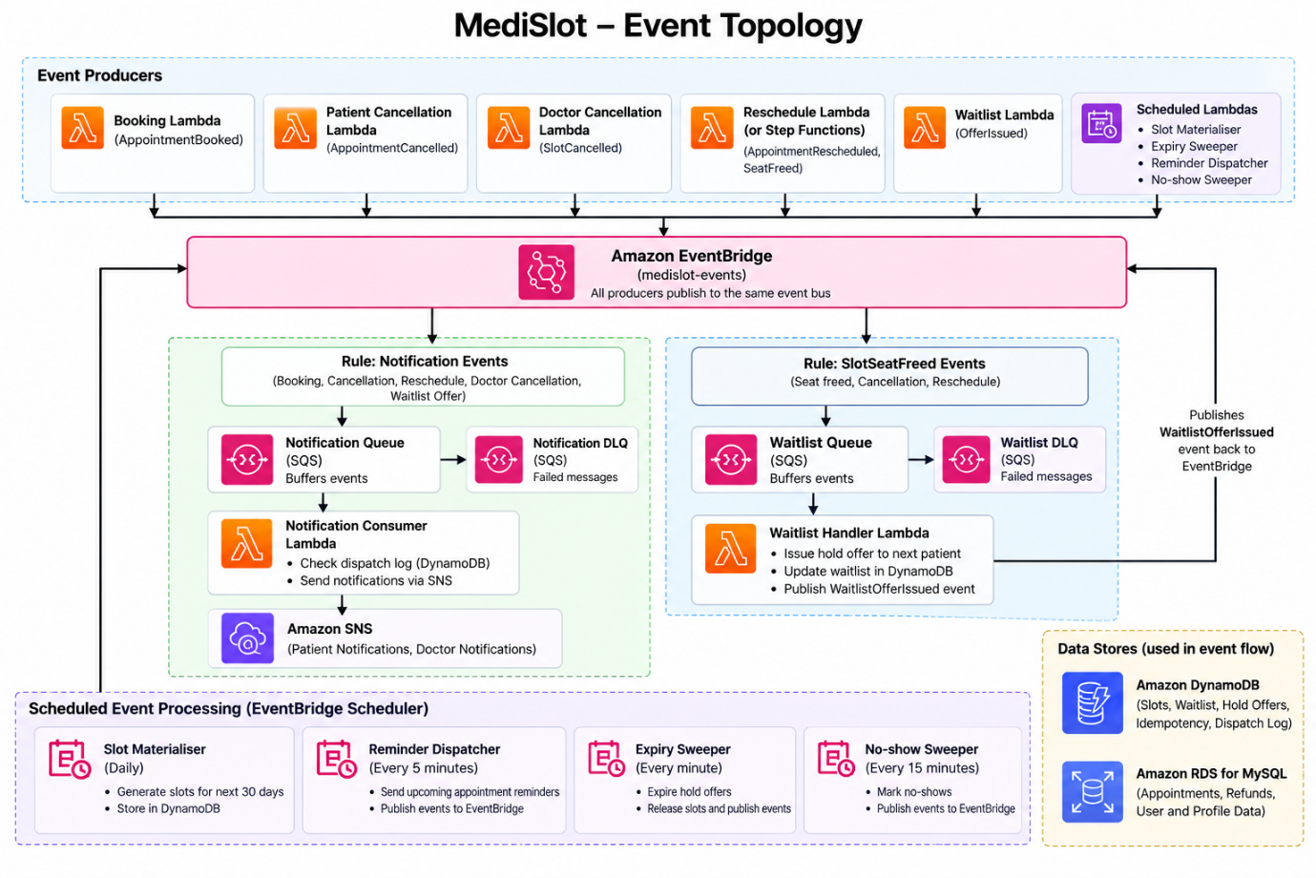
MediSlot uses event-driven processing to separate appointment operations from asynchronous notification and waitlist tasks.
Notification flow:
Booking or cancellation Lambda → Amazon EventBridge → Notification SQS Queue → Notification Lambda → Amazon SNS.
Waitlist flow:
A slot becomes available → Amazon EventBridge → Waitlist SQS Queue → Waitlist Lambda → DynamoDB hold offer.
Each consumer queue has a separate dead-letter queue to capture messages that repeatedly fail processing.
EventBridge Scheduler triggers scheduled tasks, including rolling 30-day slot generation, appointment reminders, temporary hold expiry checks, and no-show processing.

CI/CD Pipeline
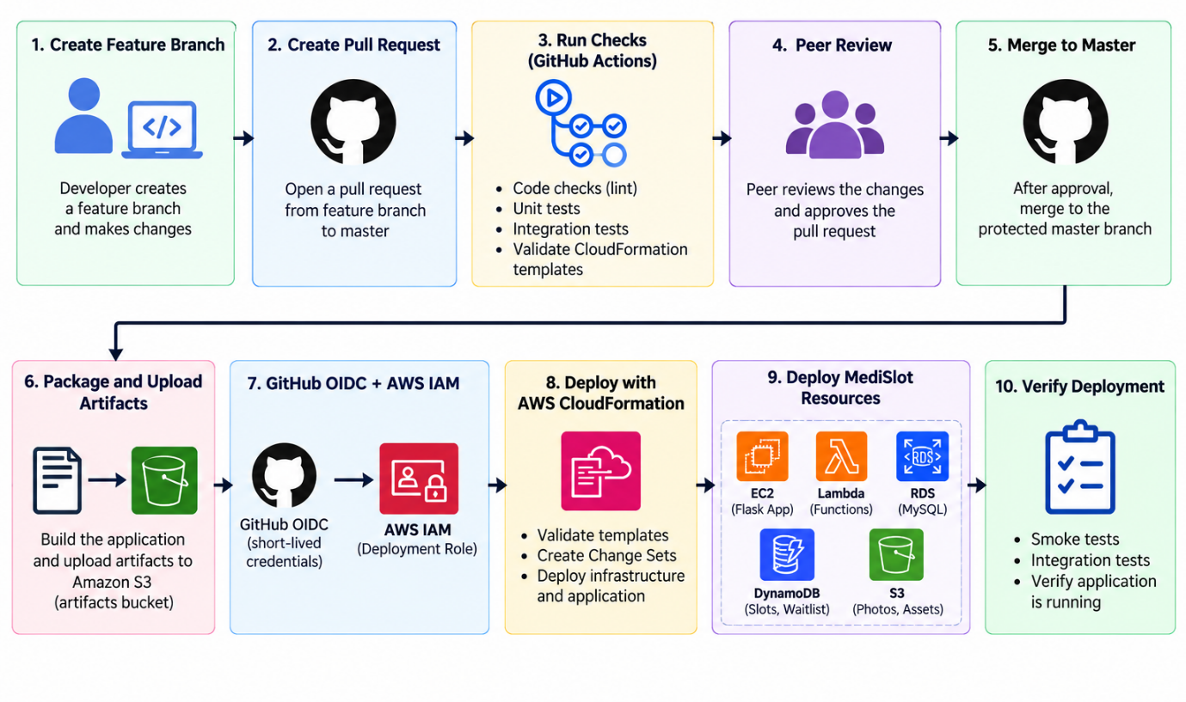

MediSlot uses GitHub Actions and AWS CloudFormation to automate application and infrastructure deployment.
- Developers create a feature branch and open a pull request.
- GitHub Actions runs code checks, tests, and infrastructure template validation.
- A peer reviews the changes and approves the pull request.
- Approved changes are merged into the protected master branch.
- The pipeline packages the application and stores required artifacts in the designated S3 bucket.
- GitHub Actions uses GitHub OIDC to obtain temporary AWS credentials through an IAM deployment role.
- CloudFormation validates templates and creates Change Sets.
- The approved infrastructure and application changes are deployed in the required stack order.
- Smoke tests and integration tests verify the deployment.
Complete RDS MySQL schema
The following SQL creates all 12 tables with their columns, data types, primary keys, indexes, and foreign-key relationships.
MediSlot – RDS MySQL Tables
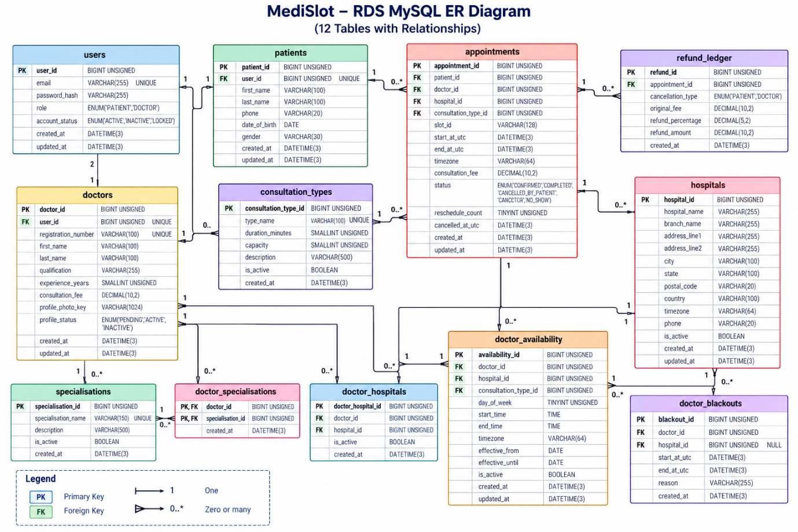

1. Users Table
Column | Data Type | Key / Constraint
user_id | BIGINT UNSIGNED | Primary Key, Auto Increment
email | VARCHAR(255) | Unique, Not Null
password_hash | VARCHAR(255) | Not Null
role | ENUM('PATIENT','DOCTOR') | Not Null
account_status | ENUM('ACTIVE','INACTIVE','LOCKED') | Default ACTIVE
created_at | DATETIME(3) | Not Null
updated_at | DATETIME(3) | Not Null

2. Patients Table
Column | Data Type | Key / Constraint
patient_id | BIGINT UNSIGNED | Primary Key, Auto Increment
user_id | BIGINT UNSIGNED | Foreign Key, Unique
first_name | VARCHAR(100) | Not Null
last_name | VARCHAR(100) | Not Null
phone | VARCHAR(20) | Nullable
date_of_birth | DATE | Nullable
gender | VARCHAR(30) | Nullable
created_at | DATETIME(3) | Not Null
updated_at | DATETIME(3) | Not Null
Foreign key: user_id → users.user_id

3. Doctors Table
Column | Data Type | Key / Constraint
doctor_id | BIGINT UNSIGNED | Primary Key, Auto Increment
user_id | BIGINT UNSIGNED | Foreign Key, Unique
registration_number | VARCHAR(100) | Unique, Not Null
first_name | VARCHAR(100) | Not Null
last_name | VARCHAR(100) | Not Null
qualification | VARCHAR(255) | Nullable
experience_years | SMALLINT UNSIGNED | Default 0
consultation_fee | DECIMAL(10,2) | Not Null
profile_photo_key | VARCHAR(1024) | Nullable
profile_status | ENUM('PENDING','ACTIVE','INACTIVE') | Default PENDING
created_at | DATETIME(3) | Not Null
updated_at | DATETIME(3) | Not Null
Foreign key: user_id → users.user_id
4. Hospitals Table
Column | Data Type | Key / Constraint
hospital_id | BIGINT UNSIGNED | Primary Key, Auto Increment
hospital_name | VARCHAR(255) | Not Null
branch_name | VARCHAR(255) | Not Null
address_line1 | VARCHAR(255) | Not Null
address_line2 | VARCHAR(255) | Nullable
city | VARCHAR(100) | Not Null
state | VARCHAR(100) | Not Null
postal_code | VARCHAR(20) | Not Null
country | VARCHAR(100) | Default India
timezone | VARCHAR(64) | Not Null
phone | VARCHAR(20) | Nullable
is_active | BOOLEAN | Default TRUE
created_at | DATETIME(3) | Not Null
updated_at | DATETIME(3) | Not Null
Indexes: (city, state, is_active), (hospital_name, branch_name)

5. Doctor Hospitals Table
Column | Data Type | Key / Constraint
doctor_hospital_id | BIGINT UNSIGNED | Primary Key, Auto Increment
doctor_id | BIGINT UNSIGNED | Foreign Key
hospital_id | BIGINT UNSIGNED | Foreign Key
is_active | BOOLEAN | Default TRUE
created_at | DATETIME(3) | Not Null
Foreign keys:
- doctor_id → doctors.doctor_id
- hospital_id → hospitals.hospital_id
Unique index: (doctor_id, hospital_id)

6. Specialisations Table
Column | Data Type | Key / Constraint
specialisation_id | BIGINT UNSIGNED | Primary Key, Auto Increment
specialisation_name | VARCHAR(150) | Unique, Not Null
description | VARCHAR(500) | Nullable
is_active | BOOLEAN | Default TRUE
created_at | DATETIME(3) | Not Null

7. Doctor Specialisations Table
Column | Data Type | Key / Constraint
doctor_id | BIGINT UNSIGNED | Primary Key, Foreign Key
specialisation_id | BIGINT UNSIGNED | Primary Key, Foreign Key
created_at | DATETIME(3) | Not Null
Foreign keys:
- doctor_id → doctors.doctor_id
- specialisation_id → specialisations.specialisation_id
Composite primary key: (doctor_id, specialisation_id)
8. Consultation Types Table
Column | Data Type | Key / Constraint
consultation_type_id | BIGINT UNSIGNED | Primary Key, Auto Increment
type_name | VARCHAR(100) | Unique, Not Null
duration_minutes | SMALLINT UNSIGNED | Not Null
capacity | SMALLINT UNSIGNED | Not Null
description | VARCHAR(500) | Nullable
is_active | BOOLEAN | Default TRUE
created_at | DATETIME(3) | Not Null
9. Doctor Availability Table
Column | Data Type | Key / Constraint
availability_id | BIGINT UNSIGNED | Primary Key, Auto Increment
doctor_id | BIGINT UNSIGNED | Foreign Key
hospital_id | BIGINT UNSIGNED | Foreign Key
consultation_type_id | BIGINT UNSIGNED | Foreign Key
day_of_week | TINYINT UNSIGNED | Not Null
start_time | TIME | Not Null
end_time | TIME | Not Null
timezone | VARCHAR(64) | Not Null
effective_from | DATE | Not Null
effective_until | DATE | Nullable
is_active | BOOLEAN | Default TRUE
created_at | DATETIME(3) | Not Null
updated_at | DATETIME(3) | Not Null
Foreign keys: doctor_id → doctors, hospital_id → hospitals, consultation_type_id → consultation_types.
10. Doctor Blackouts Table
Column | Data Type | Key / Constraint
blackout_id | BIGINT UNSIGNED | Primary Key, Auto Increment
doctor_id | BIGINT UNSIGNED | Foreign Key
hospital_id | BIGINT UNSIGNED | Foreign Key, Nullable
start_at_utc | DATETIME(3) | Not Null
end_at_utc | DATETIME(3) | Not Null
reason | VARCHAR(255) | Nullable
created_at | DATETIME(3) | Not Null
Foreign keys:
- doctor_id → doctors.doctor_id
- hospital_id → hospitals.hospital_id
11. Appointments Table
Column | Data Type | Key / Constraint
appointment_id | BIGINT UNSIGNED | Primary Key, Auto Increment
patient_id | BIGINT UNSIGNED | Foreign Key
doctor_id | BIGINT UNSIGNED | Foreign Key
hospital_id | BIGINT UNSIGNED | Foreign Key
consultation_type_id | BIGINT UNSIGNED | Foreign Key
slot_id | VARCHAR(128) | DynamoDB slot reference
start_at_utc | DATETIME(3) | Not Null
end_at_utc | DATETIME(3) | Not Null
timezone | VARCHAR(64) | Not Null
consultation_fee | DECIMAL(10,2) | Not Null
status | ENUM('CONFIRMED','COMPLETED','CANCELLED_BY_PATIENT','CANCELLED_BY_DOCTOR','NO_SHOW') | Not Null
reschedule_count | TINYINT UNSIGNED | Default 0
cancelled_at_utc | DATETIME(3) | Nullable
created_at | DATETIME(3) | Not Null
updated_at | DATETIME(3) | Not Null

12. Refund Ledger Table
Column | Data Type | Key / Constraint
refund_id | BIGINT UNSIGNED | Primary Key, Auto Increment
appointment_id | BIGINT UNSIGNED | Foreign Key
cancellation_type | ENUM('PATIENT','DOCTOR') | Not Null
original_fee | DECIMAL(10,2) | Not Null
refund_percentage | DECIMAL(5,2) | Not Null
refund_amount | DECIMAL(10,2) | Not Null
refund_status | ENUM('CALCULATED','APPROVED','REJECTED') | Default CALCULATED
reason | VARCHAR(255) | Nullable
created_at | DATETIME(3) | Not Null
updated_at | DATETIME(3) | Not Null
Foreign key: appointment_id → appointments.appointment_id
Indexes: (appointment_id, created_at), (refund_status, created_at)
Overview of DynamoDB Tables
No. | Table Name | Partition Key (PK) | Sort Key (SK) | Purpose
1 | slots | slotId (String) | None | Stores appointment slots and capacity
2 | idempotency | idemKey (String) | None | Prevents duplicate booking requests
3 | waitlist | slotId (String) | SK (String) | Stores waitlist entries and patient guards
4 | hold-offers | offerId (String) | None | Stores temporary seat offers
5 | auth-tokens | tokenId (String) | None | Stores refresh-token hashes and revoked access-token IDs
6 | dispatch-log | dispatchKey (String) | None | Prevents duplicate notification dispatch attempts
Common configuration: Enable point-in-time recovery (PITR) on all six tables. TTL is used for cleaning up expired records, not for triggering business actions.
Table 1: slots
Purpose
Stores appointment slots generated from doctors' availability in RDS MySQL.

Attribute | Data Type | Key/Type | Description
slotId | String | Partition key | Unique slot identifier
doctorId | String | Attribute | Doctor identifier from RDS
consultationTypeId | String | Attribute | Consultation type identifier
startUtc | String | GSI sort key | Slot start time in UTC, ISO-8601
endUtc | String | Attribute | Slot end time in UTC, ISO-8601
tz | String | Attribute | IANA timezone, such as Asia/Kolkata
localDate | String | Attribute | Slot date in the doctor's local timezone
capacity | Number | Attribute | Maximum number of appointments
bookedCount | Number | Attribute | Number of confirmed seats
heldCount | Number | Attribute | Number of seats reserved by active offers
version | Number | Attribute | Incremented when the slot is updated
status | String | Attribute | OPEN or CANCELLED
expiresAt | Number | TTL attribute, optional | Unix epoch seconds for cleanup after the slot ends

Table 2: idempotency
Purpose
Prevents duplicate appointments when a patient submits the same booking request multiple times due to retries, slow responses, or network errors.

Attribute | Data Type | Key/Type | Description
idemKey | String | Partition key | Combination of user ID and client idempotency key
userId | String | Attribute | Patient's user ID
requestHash | String | Attribute | Hash of the booking request
appointmentId | String | Attribute | ID of the resulting appointment, once known
status | String | Attribute | Processing state
responseData | Map | Attribute, optional | Data needed to replay the original response
createdAt | String | Attribute | Creation timestamp
expiresAt | Number | TTL attribute | Expiration time, 24 hours after creation

Table 3: waitlist
Purpose
Stores patients waiting for fully booked appointment slots.
It supports:
- Finding the first patient waiting for a slot.
- Preventing duplicate waitlist entries for the same patient and slot.
- Finding all waitlists belonging to a patient.
- Enforcing the maximum of five waitlists per patient.
Attribute | Data Type | Key/Type | Description
slotId | String | Partition key | Appointment slot identifier
SK | String | Sort key | Waitlist entry or patient guard identifier
patientId | String | GSI partition key | Patient identifier
joinedAt | String | Attribute | Time the patient joined
status | String | Attribute | For example, WAITING, OFFERED, or REMOVED
offerId | String | Attribute, optional | Associated temporary offer
createdAt | String | Attribute | Record creation time
Table 4: hold-offers
Purpose
Stores temporary appointment seat offers sent to patients on a waitlist.
Attribute | Data Type | Key/Type | Description
offerId | String | Partition key | Unique offer identifier
slotId | String | GSI partition key | Slot being offered
patientId | String | GSI partition key | Patient receiving the offer
expiresAt | Number | GSI sort key and TTL candidate | Offer expiry in Unix epoch seconds
status | String | Attribute | ACTIVE, ACCEPTED, EXPIRED, or CANCELLED
activeBucket | String | Sparse GSI partition key | Present while the offer is active
createdAt | String | Attribute | Offer creation timestamp
acceptedAt | String | Attribute, optional | Offer acceptance timestamp
Primary Key
- PK: offerId — String
- SK: None
Table 5: auth-tokens
Purpose
Stores authentication token records to support refresh-token validation and access-token revocation.
It supports:
- Refresh-token validation.
- Refresh-token revocation.
- Access-token denylisting after logout.
Schema
Attribute | Data Type | Key/Type | Description
tokenId | String | Partition key | Refresh-token hash or access-token JTI identifier
userId | String | Attribute | User identifier
tokenType | String | Attribute | REFRESH or DENYLIST
expiresAt | Number | TTL attribute | Expiry in Unix epoch seconds
createdAt | String | Attribute | Creation timestamp
revokedAt | String | Attribute, optional | Revocation timestamp
Table 6: dispatch-log
Purpose
Tracks notification dispatch intent so that retries do not routinely send the same notification multiple times.
For example, a patient may receive appointment confirmation and reminder notifications.
Schema
Attribute | Data Type | Key/Type | Description
dispatchKey | String | Partition key | Unique notification dispatch key
appointmentId | String | Attribute | Appointment identifier
eventOrInterval | String | Attribute | Event type or reminder interval
recipient | String | Attribute | Notification recipient identifier
status | String | Attribute | For example, PENDING, SENT, or FAILED
createdAt | String | Attribute | Dispatch record creation time
sentAt | String | Attribute, optional | Successful dispatch timestamp
expiresAt | Number | TTL attribute, optional | Configurable cleanup time

Concurrency Strategy
1. Contended Resource
The contended resource is the individual appointment slot item in the DynamoDB slots table. Its capacity, bookedCount, heldCount, version, and status attributes determine whether a seat is available.
A seat is available when:
bookedCount + heldCount < capacity
2. Conditional Write
The Booking Lambda uses an atomic DynamoDB UpdateItem operation to claim a seat.
UpdateExpression
SET bookedCount = bookedCount + :one,
version = version + :one
ConditionExpression
version = :expectedVersion
AND status = :open
AND bookedCount + heldCount < capacity
ReturnValuesOnConditionCheckFailure
ALL_OLD
The capacity condition prevents overbooking, while the version condition detects concurrent modifications.
3. Conflict Retry Strategy
When a ConditionalCheckFailedException occurs, the Lambda examines the returned slot item.
- If bookedCount + heldCount >= capacity, return HTTP 409 Conflict.
- If the slot remains open and has capacity, retry using the latest version.
- Use exponential backoff with full jitter to reduce repeated conflicts.
- Increment the CloudWatch BookingConflictRetries metric for each retry.
4. Bounded Retries
Retry configuration is stored in AWS Systems Manager Parameter Store (SSM).
Setting | Initial Value
Maximum attempts | 5
Base delay | 20 ms
Maximum delay | 400 ms
Retry algorithm | Exponential backoff with full jitter
The effective attempt limit is:
max(configured attempts, capacity + 1)
If the retry limit is exhausted while the slot still has capacity, return HTTP 503 Service Unavailable with a Retry-After header. Do not incorrectly report that the slot is full.
If the slot is full, return HTTP 409 Conflict and increment BookingsRejectedFull.

Reschedule Saga
1. Overview
MediSlot uses an AWS Step Functions Standard Workflow to coordinate appointment rescheduling across RDS MySQL and DynamoDB.
The workflow reserves the target slot, releases the original slot, updates the appointment in RDS MySQL, and publishes the required events.
If a step fails after an earlier step succeeds, the workflow executes a compensating action or recovery process to restore a consistent state.
Objective: The patient should retain the original confirmed appointment if rescheduling fails, or have the new appointment confirmed if rescheduling succeeds.
2. Step Sequence
Step 1: Validate Appointment
Component: Reschedule Lambda
- Verify that the appointment belongs to the requesting patient.
- Check that the appointment status is CONFIRMED.
- Verify that reschedule_count is below the configured maximum of 2.
- Ensure the original appointment starts more than 6 hours in the future.
- Verify that the target slot is open and differs from the original slot.
Failure handling: Return HTTP 400 or 409. No compensation is required because no data has changed.
Step 2: Claim the Target Seat
Component: Reschedule Lambda + DynamoDB slots
Use an atomic conditional update on the target slot.
UpdateExpression:
SET bookedCount = bookedCount + :one,
version = version + :one

ConditionExpression:
version = :expectedVersion
AND status = :open
AND bookedCount + heldCount < capacity
- Retry version conflicts within the configured limit.
- If the target slot is full, return HTTP 409.
- Record the target seat claim so it can be safely compensated if a later step fails.
Failure handling: If the claim fails, the original appointment remains confirmed. If the result is uncertain because of a timeout, inspect the slot state before retrying.
Step 3: Release the Original Seat
Component: Reschedule Lambda + DynamoDB slots
Release the original appointment's seat using a conditional update.
UpdateExpression:
SET bookedCount = bookedCount - :one,
version = version + :one

ConditionExpression:
version = :expectedVersion
AND bookedCount > :zero
- Retry safe version conflicts.
- Verify the outcome before attempting a repeated release.
Failure handling: If the release definitely fails, release the target seat that was claimed in Step 2. If the release outcome is uncertain, reconcile the slot state first.
Step 4: Update the Appointment
Component: Reschedule Lambda + RDS MySQL
Update the existing appointment within one MySQL transaction.
Update the following fields:
- slot_id
- start_at_utc
- end_at_utc
- timezone, if required by the target slot
- reschedule_count
Use a conditional update that verifies the appointment is still CONFIRMED and has not been changed by another reschedule request.
Failure handling: If the transaction rolls back, restore the original seat and release the target seat, provided the persisted state confirms those actions are safe.
If the transaction commits but its response is lost, check the database before deciding whether to compensate.
Step 5: Publish Events
Component: Amazon EventBridge
Publish these events after the appointment and slot updates have been reconciled:
- AppointmentRescheduled — identifies the successful reschedule.
- SlotSeatFreed — identifies the released original seat so the waitlist workflow can promote the next eligible patient.
Failure handling: Retry event publication and reconcile uncertain outcomes using stable event identifiers. Do not undo a successful reschedule solely because event publication failed.
3. Failure Points and Compensating Actions
Failed Step | State at Failure | Compensating Action | Intended Final State
Validate | No state changed | None | Original appointment remains confirmed
Claim target seat | Target seat not claimed, or outcome uncertain | Retry safe conflicts; inspect state if the outcome is uncertain | Original appointment remains confirmed
Release original seat | Target seat claimed; original release failed or is uncertain | Release the target seat if the original release definitely failed; otherwise reconcile both slots | Original appointment and original seat remain intact
Update RDS | Target claimed; original released | Restore the original seat and release the target seat when safe | Original appointment remains confirmed with its original slot restored
Publish events | Appointment and slot changes completed | Retry or reconcile event publication | Reschedule remains successful; events are delivered through recovery
4. Step Functions Retry and Compensation
Each Step Functions task uses bounded retries for transient failures.
Failure Type | Action
Conditional version conflict | Retry using the latest slot version
Target slot full | Stop and return HTTP 409
RDS transaction failure | Roll back the transaction and compensate earlier slot changes
Lambda timeout | Inspect persisted state before retrying or compensating
EventBridge publication failure | Retry event publication without repeating the reschedule
Compensation failure | Record the failure, alert through CloudWatch, and invoke recovery or reconciliation
Compensation operations must be idempotent so that retries cannot release the same seat twice.
5. Idempotency and Monitoring
Idempotency
Use the DynamoDB idempotency table to track the reschedule request.
The record should include the request key, operation status, and enough information to recover the final result.
Repeated requests must not start a second reschedule for an operation that is already in progress or completed.
Monitoring
Use Amazon CloudWatch to monitor:
- ReschedulesCompensated
- Reschedule Lambda errors
- Step Functions execution failures
- Slot claim and release conflicts
- Failed event publication
- Compensation and reconciliation failures
Every compensation path should log the correlation ID, failed step, compensation result, and final outcome.
6. API Workflow
Patient
|
v
API Gateway
|
v
Reschedule Lambda
|
v
Step Functions Standard Workflow
|
v
Validate Appointment
|
v
Claim Target Seat
(DynamoDB: slots)
|
v
Release Original Seat
(DynamoDB: slots)
|
v
Update Appointment
(RDS MySQL)
|
v
Publish Events
(EventBridge)
|
v
Return Final Outcome
Failure Path
Step Failure
|
v
Bounded Retry
|
v
Retry Exhausted?
|
+---- No ----> Retry Task
|
+---- Yes ---> Compensation / Recovery
|
v
Reconcile RDS
and DynamoDB
|
v
Record Outcome
in CloudWatch
7. Important Design Consideration
Releasing the original seat before updating RDS creates a risk: another patient could claim the freed seat before the RDS transaction succeeds. If the RDS update then fails, the original seat may no longer be available for restoration.
This is a known weakness of the current sequence.
Before implementation, review the ordering with your mentor. An alternative is to claim the target seat, update RDS, and then release the original seat. However, that ordering also requires recovery logic if the RDS transaction commits but releasing the original seat fails.
Event Catalogue: Event Names
No. | Event Name | Purpose
1 | AppointmentBooked | Triggered when an appointment is successfully booked.
2 | AppointmentRescheduled | Triggered when an appointment is successfully rescheduled.
3 | AppointmentCancelled | Triggered when an appointment is cancelled.
4 | SlotSeatFreed | Indicates that a booked seat has been released and may be offered to a waitlisted patient.
5 | AppointmentCompleted | Indicates that an appointment has been completed.
6 | AppointmentNoShow | Indicates that an appointment has been marked as a no-show.
7 | WaitlistOfferCreated | Indicates that a temporary waitlist offer has been created.
8 | WaitlistOfferAccepted | Indicates that a patient has accepted a waitlist offer.
9 | WaitlistOfferExpired | Indicates that a waitlist offer has expired.
10 | ReminderDue | Indicates that an appointment reminder is due.
11 | RescheduleCompensationRequired | Indicates that a failed reschedule requires compensation or reconciliation.

Event Payload Shapes
Every event contains common fields: eventId, eventType, version, occurredAt, and correlationId.
Event Name | Producer | Payload Fields | Consumer
AppointmentBooked | Booking Lambda | appointmentId, patientId, doctorId, slotId, startUtc, endUtc, consultationTypeId | notification-consumer
AppointmentRescheduled | Reschedule saga | appointmentId, patientId, doctorId, oldSlotId, newSlotId, newStartUtc, newEndUtc, rescheduleCount | notification-consumer
AppointmentCancelled | Cancellation Lambda | appointmentId, patientId, doctorId, slotId, cancelledBy, refundPercent, refundAmount | notification-consumer
SlotSeatFreed | Cancellation Lambda / Reschedule saga | slotId, doctorId, startUtc, reason | waitlist-handler
WaitlistOfferIssued | waitlist-handler | offerId, slotId, patientId, expiresAt | notification-consumer
WaitlistOfferExpired | Offer expiry sweeper | offerId, slotId, patientId | notification-consumer

Example: AppointmentBooked
{
"eventId": "uuid-value",
"eventType": "AppointmentBooked",
"version": 1,
"occurredAt": "2026-10-24T05:00:00Z",
"correlationId": "corr-10001",
"appointmentId": 1001,
"patientId": 201,
"doctorId": 301,
"slotId": "301#1#2026-10-25T04:30:00Z",
"startUtc": "2026-10-25T04:30:00Z",
"endUtc": "2026-10-25T05:00:00Z",
"consultationTypeId": 1
}
API Surface
All endpoints use one API Gateway REST API. Registration, login, and token refresh are public; all other endpoints use the Lambda Authorizer.
1. Authentication Endpoints
Method | Path | Role | Purpose
POST | /auth/doctors/register | Public | Create doctor account
POST | /auth/doctors/login | Public | Return access JWT and refresh token
POST | /auth/patients/register | Public | Create patient account
POST | /auth/patients/login | Public | Return access JWT and refresh token
POST | /auth/refresh | Public | Rotate tokens
POST | /auth/logout | Doctor/Patient | Revoke tokens

2. Doctor Endpoints
Role required: Doctor
Method | Path | Purpose
GET | /doctors/me | Read own profile
PUT | /doctors/me | Update own profile
POST | /doctors/me/photo | Get pre-signed S3 upload URL
POST | /doctors/me/consultation-types | Create consultation type
GET | /doctors/me/consultation-types | List consultation types
PUT | /doctors/me/consultation-types/{typeId} | Update consultation type
DELETE | /doctors/me/consultation-types/{typeId} | Deactivate consultation type
PUT | /doctors/me/availability | Update weekly availability
POST | /doctors/me/blackouts | Add blackout date
GET | /doctors/me/blackouts | List blackout dates
DELETE | /doctors/me/blackouts/{blackoutId} | Remove blackout date
GET | /doctors/me/schedule?date= | View daily schedule
GET | /doctors/me/appointments?from=&to=&status= | List appointments by date and status
DELETE | /doctors/me/slots/{slotId} | Cancel slot and fully refund affected patients
POST | /doctors/me/appointments/{id}/outcome | Mark appointment completed or no-show

3. Patient Endpoints
Role required: Patient
Method | Path | Purpose
GET, PUT, DELETE | /patients/me | Read, update, or delete own profile
GET | /doctors?name=&hospital=&specialisation=&city= | Search doctors
GET | /doctors/{doctorId} | View doctor profile, consultation types, and fees
GET | /doctors/{doctorId}/slots?from=&to=&consultationTypeId= | View available slots
POST | /appointments | Book appointment; requires Idempotency-Key
GET | /appointments | List upcoming and past appointments
GET | /appointments/{id} | View appointment
PATCH | /appointments/{id} | Reschedule appointment
DELETE | /appointments/{id} | Cancel appointment and calculate refund
POST | /slots/{slotId}/waitlist | Join waitlist
DELETE | /slots/{slotId}/waitlist | Leave waitlist
GET | /patients/me/waitlists | View waitlists and pending offers
POST | /waitlist-offers/{offerId}/accept | Accept waitlist offer
GET | /patients/me/refunds | View refund ledger

4. API Status Codes
Status Code | Meaning
200 | Successful request
201 | Resource created
202 | Reschedule request accepted
400 | Invalid request or missing required field
401 | Missing, expired, invalid, or revoked token
403 | Wrong role or access to another user's resource
404 | Resource not found
409 | Slot full, duplicate booking, reschedule restriction, or waitlist limit
429 | Rate limit exceeded
503 | Booking retries exhausted; retry according to Retry-After
MediSlot Authentication Design
MediSlot uses AWS Lambda functions for registration, login, token refresh, logout, and JWT validation through a Lambda Authorizer.
1. Token Configuration
Feature | Access Token | Refresh Token
Format | JWT (HS256) | Opaque random string
Lifetime | 15 minutes | 7 days
Storage | Flask server-side session | SHA-256 hash in DynamoDB auth-tokens
Revocation | jti added to denylist | Token record deleted
Lifetime configuration | SSM Parameter Store | SSM Parameter Store
Access tokens are never stored in browser cookies or local storage. Refresh-token records use TTL for expiration.
2. Access Token Claims
The JWT contains exactly five claims:
Claim | Description
sub | User ID
role | doctor or patient
iat | Token issue time
exp | Expiration time, 15 minutes after issue
jti | Unique token ID used for revocation
3. Password Security
- Passwords are hashed using bcrypt with a work factor of 12 or higher, configurable through SSM.
- Passwords must contain at least 10 characters, including one letter and one digit.
- An upper length limit is enforced because bcrypt processes only the first 72 bytes.
- Unknown email addresses and incorrect passwords return the same 401 Unauthorized response.
4. Signing Secret Management
The JWT signing secret is stored as an SSM Parameter Store SecureString, encrypted using the AWS-managed aws/ssm key.
- The operator creates the secret through a documented runbook.
- The secret is never stored in source code, CloudFormation templates, or hard-coded environment variables.
- Login, refresh, and authorizer Lambdas read the secret at cold start.
- Each Lambda execution role receives permission to read only the required parameter.
- Rotating the secret invalidates tokens signed with the previous secret; users must log in again.
The Flask session cookie uses a separate signing secret, also stored as an SSM SecureString.
5. Authentication Flows
Registration
- Validate the password policy.
- Hash the password using bcrypt.
- Insert the user into the users table and the appropriate role table.
- Enforce email uniqueness across doctors and patients.
Login
- Verify the password hash.
- Generate an access JWT and an opaque refresh token.
- Store the refresh token's SHA-256 hash in DynamoDB.
- Return both tokens; Flask keeps them in its server-side session.
Every API Request
- Flask sends the access token to API Gateway.
- The Lambda Authorizer verifies the signature and expiration.
- It checks the jti against the denylist.
- It returns an IAM policy and the authenticated userId and role in the authorizer context.
- API handlers obtain the acting user's identity from this context.
Refresh
- Hash the presented refresh token.
- Look up the hash in DynamoDB.
- Delete the existing token record.
- Issue a new access token and refresh token.
- Reject reuse of the old refresh token.
Logout
- Delete the refresh-token record.
- Add the access token's jti to the denylist.
- Set the denylist TTL to the token's remaining lifetime.
- Reject subsequent requests using that token with 401 Unauthorized.
6. Role Enforcement
Role | Access
Doctor | Doctor-specific API routes
Patient | Patient-specific API routes
Wrong role | 403 Forbidden
Missing, expired, tampered, or revoked token | 401 Unauthorized
Flask's /doctor/* and /patient/* blueprints also check the role stored in the session. This controls web navigation; API security is enforced independently by the Lambda Authorizer.
7. Authorizer Caching
The proposed API Gateway authorizer cache TTL is 0 seconds, meaning caching is disabled.
This ensures logout revocation is checked on subsequent requests rather than relying on a cached authorization result. The trade-off is an additional authorizer invocation and DynamoDB denylist read per request.
MediSlot CI/CD Pipeline Design
1. CI/CD Pipeline Flow
The MediSlot project uses GitHub Actions and AWS CloudFormation to automate code validation, testing, and deployment.
Pipeline Flow:
Developer Branch
|
v
Pull Request to master
|
v
GitHub Actions
(Lint + Unit Tests + Security Scans)
|
v
One Approving Review
+ Required Checks Pass
|
v
Merge to master
|
v
Build and Package
(Lambda Code + Web Assets)
|
v
Upload Versioned Artifacts to Private S3
|
v
Assume AWS Role Using GitHub OIDC
|
v
CloudFormation Template Validation
|
v
Create Change Set
|
v
Review and Execute Change Set
|
v
Smoke and Integration Tests
|
v
Deployment Summary
2. Pipeline Stages
Stage | Description
Pull Request | Developer submits changes for review.
Code Validation | Run Python linting, formatting, and static analysis.
Testing | Execute unit tests and API/schema checks.
Security Scanning | Scan for secrets, vulnerable dependencies, and infrastructure risks.
Approval | Require one approving review and passing status checks.
Build and Package | Package Lambda functions and web assets.
Artifact Storage | Upload versioned artifacts to a private S3 bucket.
AWS Authentication | Assume a restricted AWS IAM role using GitHub OIDC.
Infrastructure Deployment | Validate CloudFormation templates, create a Change Set, review, and execute it.
Post-Deployment Testing | Run smoke and integration tests on critical booking flows.

3. GitHub Secrets and Variables Strategy
MediSlot uses GitHub OIDC to authenticate GitHub Actions with AWS without storing long-lived AWS access keys.
Name | Storage | Purpose
AWS_ROLE_ARN | GitHub variable | IAM deployment role ARN
AWS_REGION | GitHub variable | AWS deployment region
ARTIFACT_BUCKET | GitHub variable | Private S3 artifact bucket
CLOUDFORMATION_STACK_PREFIX | GitHub variable | Consistent CloudFormation stack naming
DEPLOY_ENVIRONMENT | Protected environment variable | Identifies the deployment environment
JWT signing secret | SSM SecureString | Signs and validates access tokens
RDS password | SSM SecureString or approved secret store | Authenticates to RDS MySQL
SNS topic ARNs | CloudFormation outputs or variables | Identifies notification topics
AWS access keys | Not required | OIDC provides short-lived credentials

MediSlot project Stacks
Order | CloudFormation Stack | Resources included
1 | medislot-bootstrap | GitHub OIDC, deployment IAM role, S3 artifact bucket
2 | medislot-network | VPC, subnets, route tables, security groups, VPC endpoints
3 | medislot-data | RDS MySQL and DynamoDB tables
4 | medislot-config | SSM Parameter Store configuration and secret references
5 | medislot-iam | IAM execution roles and permissions for Lambda functions
6 | medislot-auth | Authentication Lambda, Lambda Authorizer, API Gateway authentication integration
7 | medislot-doctor | Doctor profile creation and update Lambda
8 | medislot-appointments | Booking Lambda, patient cancellation Lambda, doctor cancellation Lambda
9 | medislot-reschedule | Reschedule Lambda and Step Functions rescheduling saga
10 | medislot-notifications | EventBridge, SQS, DLQ, notification Lambda, SNS
11 | medislot-web | EC2 instance hosting the Flask patient and doctor dashboard
12 | medislot-monitoring | CloudWatch logs, metrics, dashboards, and alarms
Deployment dependency: Network → Data → Configuration → IAM → Authentication and application stacks → Notifications → Web → Monitoring. Bootstrap must be deployed first. Ensure that each stack's dependencies and CloudFormation exports are available before deployment.

2. Lambdas architecture
Order | Lambda function | Responsibility
1 | AuthenticationLambda | Doctor and patient registration and login
2 | AuthorizerLambda | Validate access tokens and authorize API requests
3 | DoctorLambda | Create and update doctor profiles
4 | BookingLambda | Book appointments and initiate booking events
5 | PatientCancellationLambda | Cancel patient appointments and process cancellation logic
6 | DoctorCancellationLambda | Handle doctor cancellations and affected appointments
7 | RescheduleLambda | Initiate appointment rescheduling
8 | NotificationLambda | Process notification messages and publish notifications
9 | WaitlistHandlerLambda | Process freed slots and waitlist opportunities
10 | OfferExpiryLambda | Handle expired waitlist offers
11 | ReminderDispatcherLambda | Dispatch scheduled appointment reminders

GitHub OIDC Authentication
The deployment role trusts GitHub's OIDC provider and is restricted to the MediSlot repository and the master branch.
A separate IAM role with test-only permissions is used for pull request workflows.
- Workflows request only id-token: write and contents: read permissions, adding other permissions only when required.
- Third-party GitHub Actions are pinned to a specific commit SHA.
- Deployment jobs use OIDC to obtain temporary AWS credentials.
- If OIDC cannot be used, a least-privilege IAM user is the fallback. Its access keys would be stored in a protected GitHub Environment secret. This is not the planned approach.

GitHub Variables and Secrets
No GitHub secrets are required for the normal deployment pipeline.
Name | Type / Storage | Purpose
AWS_ROLE_ARN | GitHub repository or protected environment variable | Identifies the AWS deployment role; it is not a credential by itself.
AWS_REGION | GitHub variable | Specifies the AWS deployment region, such as ap-south-1 if confirmed for the project.
ARTIFACT_BUCKET | GitHub variable | Identifies the private S3 artifact bucket.
CLOUDFORMATION_STACK_PREFIX | GitHub variable | Maintains consistent CloudFormation stack naming.
DEPLOY_ENVIRONMENT | Protected GitHub environment variable | Identifies the target environment, such as dev or test. Production should be protected separately if introduced.
JWT signing secret | SSM Parameter Store SecureString | Runtime secret read by authorized Lambda functions.
RDS password | SSM Parameter Store SecureString or approved secret store | Database authentication credential.
SNS topic ARNs and resource names | CloudFormation outputs or GitHub variables | Resource identifiers that do not need to be stored as secrets.
AWS access key and secret key | Not required for the normal pipeline | OIDC provides temporary AWS credentials.

